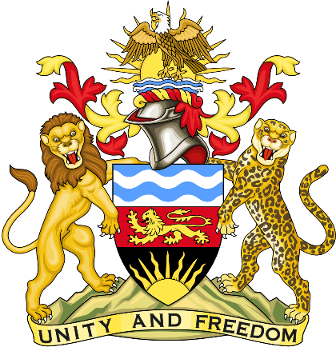

Statement delivered by Pacharo Kayira
Deputy Permanent Representative of the Republic of Malawi to the United Nations and other International Organisations in Geneva

39th Session of the Working Group of the Universal Periodic Review

Review of the Ireland

10 November 2021

Madam President.

Malawi welcomes Ireland to the review and thanks the delegation for a comprehensive presentation.

Malawi commends Ireland for amending the Criminal Law (Sexual Offences) Act in 2017 and 2019 to improve protection of children from sexual abuse, exploitation and grooming. We note that the legal provisions now criminalise purchase of sexual services, curb child sexual abuse material and impose enhanced penalties for repeat sexual offenders.

In the spirit of constructive dialogue, Malawi makes the following recommendations to Ireland:

- Effectively implement the provisions of the Criminal Law (Sexual Offences) Acts of 2017 and 2019 to prevent sexual abuse and exploitation of children, assist victims and prosecute perpetrators.

- Consider acceding to the Optional Protocol to the Convention on the Rights of the Child on the sale of children, child prostitution and child pornography.

- Consider acceding to the Convention for the Protection of All Persons from Enforced Disappearance.

Malawi wishes Ireland a successful review.

Thank you, Madam President.

