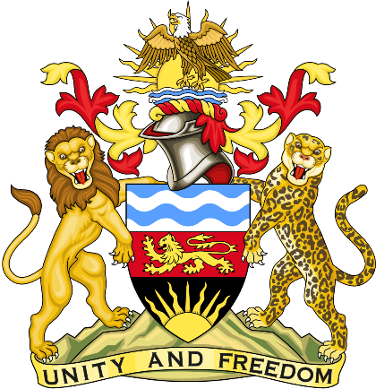

Statement delivered by Pacharo Kayira
Deputy Permanent Representative of the Republic of Malawi to the United Nations and other International Organisations in Geneva

39th Session of the Working Group of the Universal Periodic Review

Review of Hungary

2 November 2021

Madam President.

Malawi welcomes Hungary to this universal periodic review and thanks the delegation for the detailed presentation.

Malawi applauds the child protection and family support policies the Government of Hungary has implemented. These include protection of children from trafficking, benefits for parents taking care of severely disabled or ill children, chid tax allowances and care fees, as well as subsidies to set up family homes. We also note the steps being taken by Hungary to train police officers and to prosecute anti-Semitic, religious, racial and xenophobic hate crimes.

Malawi makes the following recommendations to Hungary in the spirit of constructive dialogue:

- Increase efforts to raise public awareness on tolerance and vigorously prosecute all hate crimes to prevent discrimination and protect the human rights of all people.
- Raise the legal age for marriage to 18 years for men and women without exception.

- Ratify the Convention for the Protection of All Persons from Enforced Disappearance.

Malawi wishes Hungary a successful review.

Thank you, Madam President.

