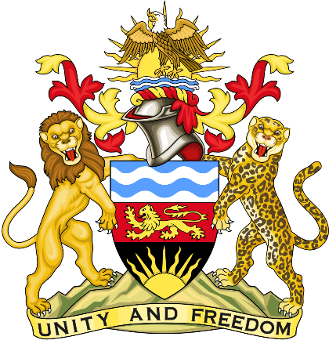

Statement delivered by Pacharo Kayira
Deputy Permanent Representative of the Republic of Malawi to the United Nations and other International Organisations in Geneva

39th Session of the Working Group of the Universal Periodic Review

Review of Greece

1 November 2021

Thank you, Madam President.

Malawi welcomes Greece to this review and thanks the delegation for the comprehensive presentation.

Malawi notes the important measures taken by Greece to implement action plans to combat racial discrimination, enhance the rights of persons with disability and reduce child poverty.

In the spirit of constructive dialogue, Malawi makes the following recommendations to Greece:

- Conclude the National Strategy for Social Integration and Poverty Reduction launched in June 2021 to address root causes of poverty, and implement programmes that mitigate the effects of the COVID-19 pandemic on employment and livelihoods to ensure all children and other household members can live in dignity and access affordable public services.

- Provide support for inclusion of recent migrants in society and continue to cooperate with African and other nations to implement policies that ensure safe and orderly migration that protects the human rights of all people.

We wish Greece every success at this review.

Thank you, Madam President.

