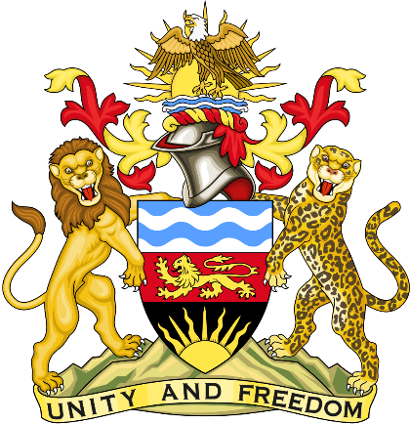

Statement delivered by Pacharo Kayira.
Deputy Permanent Representative of the Republic of Malawi to the United Nations and other International Organisations in Geneva

39th Session of the Working Group of the Universal Periodic Review

Review of the Kingdom of Eswatini

8 November 2021

Madam President.

Malawi welcomes the Kingdom of Eswatini and acknowledge the strides being made in the promotion and protection of human rights.

In the spirit of constructive dialogue, Malawi recommends the following to Kingdom of Eswatini:

- Progressively ratify key and relevant international human rights instruments.

- Increase investment in the education sector to enhance quality and accessibility of education to all.

Malawi wishes the Kingdom of Eswatini a successful review.

Thank you, Madam President.

