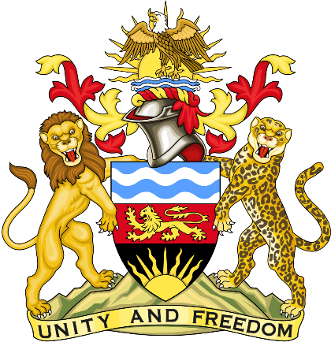

Statement delivered by Pacharo Kayira
Deputy Permanent Representative of the Republic of Malawi to the United Nations and other International Organisations in Geneva

39th Session of the Working Group of the Universal Periodic Review

Review of Antigua and Barbuda

8 November 2021

Madam President.

Malawi welcomes Antigua and Barbuda to this review and thanks the delegation for the presentation.

Malawi commends Antigua and Barbuda for the progress made since the last review such as increased training for law enforcement personnel in handling persons affected by domestic and sexual violence. Implementation of the Domestic Violence Act of 2015 has enhanced the capacity of courts to adjudicate domestic violence leading to a notable increase in cases taken to court.

Malawi notes that Antigua and Barbuda has established an Ombudsman as an independent Constitutional office with responsibility to investigate complaints by people against Government officials and statutory authorities.

In the spirit of constructive dialogue, Malawi recommends the following to Antigua and Barbuda:

- Consider establishing a national human rights institution in full compliance with the Paris Principles.

- Consider acceding to the Convention for the Protection of All Persons from Enforced Disappearance.

Malawi wishes Antigua and Barbuda a successful review.

Thank you, Madam President.

