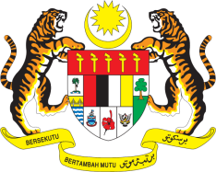

STATEMENT BY MALAYSIA
REVIEW OF THE UNITED REPUBLIC OF TANZANIA
39TH SESSION OF THE UPR WORKING GROUP
1-12 NOVEMBER 2021

Malaysia welcomes the delegation of Tanzania and thanks them for the presentation of their national report.

- Malaysia congratulates Tanzania for the conduct of its General Elections in October 2020. We welcome the strengthening of the national human rights institutions and commend Tanzania for taking positive steps to safeguard women’s empowerment.

- In the spirit of constructive engagement, Malaysia offers the following recommendations:

3.1 First, continue strengthening the enforcement of laws prohibiting violence against women and girls;

3.2 Second, take concrete measures to implement the National Anti-Trafficking in Persons Plan of Action (2018-2021) with a view to combat trafficking in persons; and

3.3 Third, continue to provide adequate resources and funding for fundamental human rights issues, including access to healthcare and education.

- Malaysia wishes Tanzania a successful review.

Thank you.

GENEVA
5 November 2021

