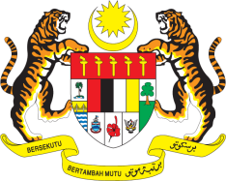

STATEMENT BY MALAYSIA
REVIEW OF SURINAME
39TH SESSION OF THE UPR WORKING GROUP
1-12 NOVEMBER 2021

Malaysia welcomes the delegation of Suriname and thanks them for the presentation of their national report.

- Malaysia commends Suriname for its accession to the Convention on the Rights of Persons with Disabilities and the various national plan and policies focusing on protecting the rights of women, children and youth. Malaysia also commends Suriname’s cooperation with the treaty bodies for capacity-building activities and the launch of National Plan of Action for the prevention of trafficking in persons.

- However, Malaysia notes the concern expressed by the Committee on the Rights of the Child about the high drop-out rate of children from school and hopes that Suriname will increase efforts to keep children in school, including raising the age of compulsory education.

- In the spirit of constructive engagement, Malaysia offers the following recommendations:

4.1 Advance the goal to establish a national human rights institution in accordance with the Paris Principles;

4.2 Consider adopting a comprehensive legislation to protect the rights of persons with disabilities;

4.3 Strengthen efforts to reduce the rate of maternal mortality; and

4.4 Continue the implementation of provisions under the National Mental Health Plan to prevent suicides among children and adolescents.

- Malaysia wishes Suriname a successful review.

Thank you.

GENEVA
1 November 2021

