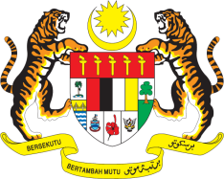

STATEMENT BY MALAYSIA
REVIEW OF SAINT VINCENT AND THE GRENADINES
39TH SESSION OF THE UPR WORKING GROUP
1-12 NOVEMBER 2021

Malaysia welcomes the delegation of Saint Vincent and the Grenadines and thanks them for the comprehensive presentation of their national report.

- Malaysia appreciates their commitments to the issues raised in the previous UPR cycle and the efforts undertaken to promote and protect the human rights.

- Malaysia commends Saint Vincent and the Grenadines for adopting positive progress in improving its judicial system, implementing social assistance programmes to reduce poverty and enhancing access to education. Malaysia is also pleased to note the comprehensive review taken by them to protect children against sexual violence and the collaboration with the UNFPA to develop technical assistance in addressing gender-based violence.

- In the spirit of constructive engagement, Malaysia offers the following recommendations:

4.1 Advance the goal to establish a national human rights institution in accordance to the Paris Principles;

4.2 Strengthen existing measures on poverty eradication to address the issue of child poverty, especially those living in rural areas; and

4.3 Continue implement measures that allow integration of children with disabilities into mainstream education.

- Malaysia wishes Saint Vincent and the Grenadines a successful review.

Thank you.

GENEVA
3 November 2021

