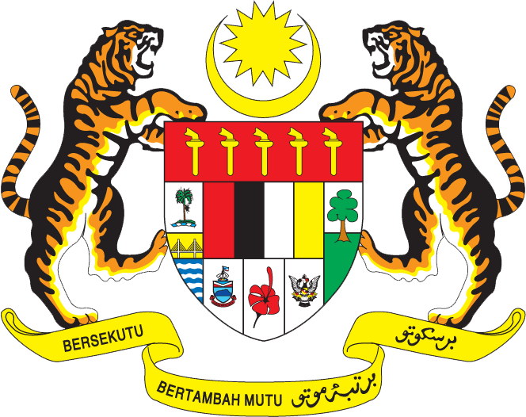

STATEMENT BY MALAYSIA
REVIEW OF PAPUA NEW GUINEA
39TH SESSION OF THE UPR WORKING GROUP
1-12 NOVEMBER 2021

Malaysia thanks Papua New Guinea for its report presentation.

- Malaysia welcomes Papua New Guinea’s participation in the UPR process and views it as an important testament to its commitment to promote and protect the human rights and fundamental freedoms of its people.

- We welcome the Government’s efforts and underline that adequate resources and improvement in basic socio-economic and development situation are essential to achieve this. In this regard, we would like to encourage Papua New Guinea to continue its engagement with the international community to address the challenges it faces with a view to improve the overall human rights situation in the country.

- In the spirit of constructive engagement, Malaysia recommends the following:

3.1. Continuing taking efforts to ensure health facilities and services be accessible to all particularly the most vulnerable;
3.2. Realise right to education including by integrating gender equality into all levels of education and ensure access to education particularly for communities in remote and rural areas; and
3.3 Establish a national human rights institution in accordance with the Paris Principles.

- Malaysia wishes Papua New Guinea a successful review.

Thank you.

GENEVA
4 November 2021

