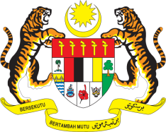

STATEMENT BY MALAYSIA
REVIEW OF GREECE
39TH SESSION OF THE UPR WORKING GROUP
1-12 NOVEMBER 2021

Malaysia welcomes the delegation of Greece and thanks them for the presentation of their national report.

- Malaysia commends Greece for adopting three National Action Plans on the rights of persons with disabilities, the rights of children and racism and intolerance during the period under review. We also commend Greece on the progress achieved in combating violence against women and the positive steps taken to combat trafficking in persons.

- Malaysia appreciated the efforts undertaken by Greece in responding to the influx of asylum seekers, migrants and refugees arriving in the country. We encourage the international community to lend its support to Greece in hosting migrants.

- In the spirit of constructive engagement, Malaysia offers the following recommendations:

4.1 Continue to take measures to protect the rights of women and children including by strengthening its existing legislation;

4.2 Improve access to health services for persons with disabilities, particularly in sexual and reproductive health services; and

4.3 Step up measures to ensure that persons with disabilities are not excluded in the distribution of welfare allowances.

- Malaysia wishes Greece a successful review.

Thank you.

GENEVA
1 November 2021

