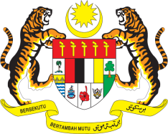

STATEMENT BY MALAYSIA
REVIEW OF ESWATINI
39TH SESSION OF THE UPR WORKING GROUP
1-12 NOVEMBER 2021

Malaysia welcomes the delegation of Eswatini and thanks them for the presentation of their national report.

- Malaysia congratulates Eswatini for making progress in the implementation of the recommendations since its previous UPR cycle. Malaysia also commends Eswatini for taking positive steps in protecting people with albinism especially women and girls from violence through law enforcement.

- We note the various initiatives undertaken by Eswatini made during the period under review, including in stepping up efforts towards pursuing the right to education and its expansion of health care programmes in the country.

- In the spirit of constructive engagement, Malaysia offers the following recommendations:

4.1 Continue its strategies and approaches in ending all forms of discrimination and violence against women and girls through effective implementation of the National Strategy and Action Plan to End Violence (2017-2022).

4.2 Allocate adequate resources and funding for the full implementation of the relevant legislative framework to protect the rights of persons with disabilities.

- Malaysia wishes Eswatini a successful review.

Thank you.

GENEVA
8 November 2021

