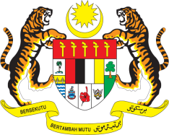

STATEMENT BY MALAYSIA
REVIEW OF ANTIGUA AND BARBUDA
39TH SESSION OF THE UPR WORKING GROUP
1-12 NOVEMBER 2021

Malaysia welcomes the delegation of Antigua and Barbuda and thanks them for the presentation of their national report.

- Despite the challenges due to the COVID-19 pandemic and the devastation caused by the 2017 Hurricane Irma, Malaysia commends Antigua and Barbuda on its rebuilding effort and the commitment to the promotion and protection of human rights attested by several legislation and policies which have been introduced and implemented throughout the review period.

- Malaysia welcomes the adoption of the Disabilities and Equal Opportunities Act of 2017 and the unveiling of the National Child Protection Policy in September 2021. Malaysia also welcomes affirmative measures to raise awareness about domestic and sexual violence against women.

- In the spirit of constructive engagement, Malaysia would like to offer Antigua and Barbuda the following recommendations:

4.1 Continue its effort to promote gender equality through pursuing the development of National Gender Policy; and

4.2 Continue strengthening measures to ensure access to healthcare by allocating adequate resources in the health sector, especially for the treatment of non-communicable diseases.

- Malaysia wishes Antigua and Barbuda a successful review.

Thank you.

GENEVA
8 November 2021

