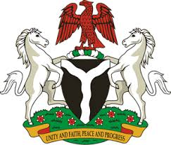
Please check against delivery

HUMAN RIGHTS COUNCIL
39TH SESSION OF THE WORKING GROUP OF THE UPR
REVIEW OF TANZANA
5TH NOVEMBER, 2021

STATEMENT BY NIGERIA
Madam President,
Nigeria warmly welcomes the delegation of the United Republic of Tanzania to the presentation of the country’s National Report for the Third Cycle UPR and commends its commitment to national, regional and international human rights obligations.
2. We applaud the Government of Tanzania for the successful implementation of its first National Human Rights Action Plan 2013-2017 and note, with satisfaction, efforts put in place to reinforce its institutional frameworks to promote and protect the rights and fundamental freedoms of the people of Tanzania.
3. While acknowledging the genuine efforts and commitments of the Government of Tanzania to promote and protect the fundamental rights of its people, we wish to recommend the need to:
- Sustain efforts and commitment in protecting the rights of women, children and people with disabilities; and
- Seek international corporation for technical assistance and capacity building in the field of human rights.
4. Finally, we wish Tanzania a very successful review.
I thank you Madam President

