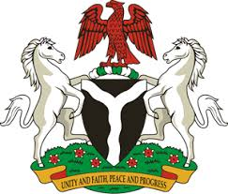
Please check against delivery

HUMAN RIGHTS COUNCIL
39TH SESSION OF THE WORKING GROUP OF THE UPR
REVIEW OF THAILAND
10TH NOVEMBER, 2021
STATEMENT BY NIGERIA
Madam Vice President,
Nigeria welcomes the delegation of the Kingdom of Thailand to the presentation of its National Report and commends the country for the comprehensive update provided today.
2. We commend the efforts of the Government of Thailand for its commitments to the fulfilment of its human rights obligations. We take positive note of the efforts of the Government to promote and protect human rights through the establishment of a 20-year National Strategy (2018-2037) and the 4th National Human Rights Plan (2019-2022).
3. In the spirit of constructive dialogue, Nigeria wishes to recommend to the Government of Thailand as follows:
- The need to strengthen efforts in eliminating of all forms of racial discrimination; and
- The need to strengthen efforts in protection of the rights of migrants and members of their families.
4. We wish the Kingdom of Thailand a very successful review process.
I thank you, Madam Vice President.
******

