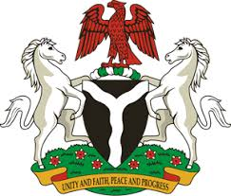
Please check against delivery
HUMAN RIGHTS COUNCIL
39TH SESSION OF THE WORKING GROUP OF THE UPR
REVIEW OF IRELAND
10TH NOVEMBER, 2021
STATEMENT BY NIGERIA
Madam Vice President,
Nigeria extends a warm welcome to the delegation of the Republic of Ireland to the presentation of the country’s National Report for the third cycle of the UPR, and commends the Government of Ireland for its cooperation with human rights mechanisms.
2. Nigeria takes positive note of measures adopted by the Government of Ireland to prevent and combat racial discrimination, human trafficking and the protection of victims of human trafficking. In addition, the policy of the Government of Ireland on the integration and inclusion of migrants and marginalised groups are noteworthy.
3. In the spirit of constructive dialogue, Nigeria wishes to offer the following recommendations to the Government of Ireland:
- To sustain its efforts in eliminating racial discrimination and combatting hate speech and other hate crimes; and
- To continue with its efforts in protecting the rights of migrants, combatting human trafficking and protecting the rights of victims of human trafficking
4. We wish Ireland every success in its review.

I thank you Madam Vice President.
******

