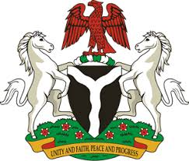
Please check against delivery
HUMAN RIGHTS COUNCIL
39TH SESSION OF THE WORKING GROUP OF THE UPR
REVIEW OF HUNGARY
2ND NOVEMBER, 2021
STATEMENT BY NIGERIA
Madam Vice President,
Nigeria welcomes the presentation of the National Report by Hungary and commends the Government of Hungary for its cooperation with human rights instruments and mechanisms.
2. We applaud the Government of Hungary for adopting the Action Plan for the implementation of the National Disability Programme, as well as the National Anti-Trafficking Strategy and Action Plan.
3. In the spirit of constructive dialogue, Nigeria wishes to offer the following recommendations to Hungary:
- To strengthen efforts in protection of the rights of migrants and members of their families; and
- To sustain and scale up its efforts in eliminating racial discrimination and combatting hate speech and other hate crimes.
4. We wish Hungary a very successful review process.

I thank you Madam Vice President.
******

