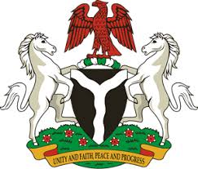
Please check against delivery

HUMAN RIGHTS COUNCIL
39TH SESSION OF THE WORKING GROUP OF THE UPR
REVIEW OF GREECE
1ST NOVEMBER, 2021

STATEMENT BY NIGERIA
Madam President
Nigeria welcomes the presentation of the UPR National Report by Greece and commends the country’s commitment to the promotion and protection of human rights, particularly the rights of migrant workers and members of their families.
2. While congratulating the government of Greece for adopting its National Action Plan on the rights of persons with disabilities and the National Action Plan against racial discrimination and intolerance, 2020-2023, Nigeria wishes to, in the spirit of constructive dialogue, make the following recommendations for consideration by Greece:
- Need to strengthen efforts in combatting racism, and to protect the rights of all migrants, particularly women and children; and
- To continue with its efforts in combating human trafficking and upholding the rights of victims in this regard.
3. In conclusion, we wish Greece every success in its review process.

I thank you Madam President

