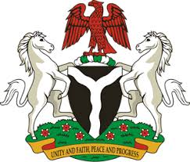
Please check against delivery

HUMAN RIGHTS COUNCIL
39TH SESSION OF THE WORKING GROUP OF THE UPR
REVIEW OF ESWATINI
8TH NOVEMBER, 2021
STATEMENT BY NIGERIA
Mr. Vice President,
Nigeria welcomes the delegation of the Kingdom of Eswatini to the presentation of the country’s National Report for the third UPR and commends its continued cooperation with human rights mechanisms as well as efforts to implement previous recommendations.
2. We take cognizance of the progress made by the Government of Eswatini in the protection and promotion of the rights of women and girls, including efforts to eliminate discrimination and inequality.
3. In the spirit of constructive dialogue, Nigeria wishes to make the following recommendations for consideration by the Kingdom of Eswatini:
- To establish the legal framework for the domestication of the Convention on the Elimination of Discrimination Against Women (CEDAW); and
- To ratify the Convention Against Torture and Other Cruel, Inhuman or Degrading Treatment or Punishment (CAT).
4. Finally, we wish the Kingdom of Eswatini a successful review.
I thank you, Mr. Vice President

