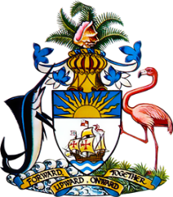

Statement by Mr. Frank Davis, Deputy Permanent Representative
Permanent Mission of The Bahamas to the United Nations Office and Other International Organizations in Geneva
at the 39thSession of the Universal Periodic Review Working Group
Presentation of National Report by the Government of Trinidad and Tobago
Monday, 8 November, 2021

Thank you, Madam/Mr.[Vice] President.
The Bahamas extends a warm welcome to the sister CARICOM delegation of Trinidad and Tobago, thanks the country for its report and commends its engagement in this UPR process.
In a constructive spirit, The Bahamas recommends that Trinidad and Tobago:

- Continues the momentum towards full compliance with its obligations under the Convention on the Rights of the Child;
and
- Maintain efforts, through the Inter-Ministerial Committee, to develop policy and legislation to protect the rights of persons with disabilities in order to address the lack of legislation and to achieve the implementation of the Convention on the Rights of Persons with Disabilities.

As a fellow CARICOM Member State and Small Island Developing State (SIDS), we recognise the challenges faced by Trinidad and Tobago, including the strain that the coronavirus pandemic has put on progress towards national goals, the challenges faced by limited human resources and the disproportionate threats posed by climate change. We encourage Trinidad and Tobago to avail itself of technical assistance and capacity-building support, in accordance with its human rights priorities and call on the international community to cooperate with the country in this regard.

We wish Trinidad and Tobago every success in this UPR process.

I thank you.

