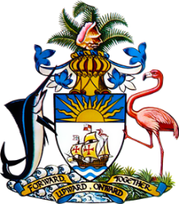

**Statement by Mr. Frank Davis, Deputy Permanent Representative**

**Permanent Mission of The Bahamas to the United Nations Office and Other International Organizations in Geneva**

**at the 39th Session of the Universal Periodic Review Working Group  
*Presentation of National Report by the Government of Thailand***

**Wednesday, 10 November 2021**

Thank you, Madam/Mr. [Vice] President.

The Bahamas extends a warm welcome to the delegation of Thailand and thanks the country for its detailed report and engagement in this UPR process.

Moreover, The Bahamas commends Thailand’s Sufficiency Economy Philosophy and its efforts towards instituting polices and regulations that support environmental protection, climate action and social and economic progress.

The Bahamas recognizes Thailand’s efforts with the establishment of the ASEAN Centre for Sustainable Development Studies and Dialogue.

In a constructive Spirit, The Bahamas **recommends** that Thailand:

1. Continues to address concerns about the prevalence of early and forced child marriage and unions

and;

1. Fully implements and considers renewing the 2018-2021 Plan to Promote Coexistence under a Multicultural Society in Thailand.

We wish Thailand every success in this UPR process.

I thank you.

(Speaking time allocated: 1 minute and 5 seconds)