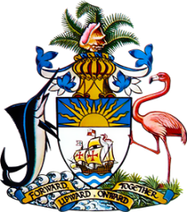

Statement by Ms. Kristie Russell, Third Secretary
Permanent Mission of The Bahamas to the United Nations Office and Other International Organizations in Geneva
at the 39th Session of the Universal Periodic Review Working Group
Presentation of National Report by the Government of Tajikistan
4th November, 2021

The Bahamas extends a warm welcome to the delegation of Tajikistan. We thank the delegation for its comprehensive report and also commend the delegation for its active and constructive engagement in this important process.
The Bahamas submits the following recommendations to Tajikistan:
- continue its efforts to ratify the Convention on the Rights of Persons with Disabilities (CRPD);
- prioritise the enactment of the draft of the new Criminal Code which intends to criminalise domestic violence, inter alia; and

- take concrete steps to address stigmatization and discrimination faced by persons living with HIV/AIDS, including in law and practice.

We highlight the commitment of Tajikistan to the protection and promotion of the human rights of all and commend the country on the steps it has taken to combat trafficking in persons, including the establishment of the Interdepartmental Commission to Combat Trafficking in Persons.

We further commend Tajikistan for adopting the Water Code on 2 April 2020 which guarantees the right of access to safe and clean drinking water as an integral component of the realization of all human rights.
We are also pleased that Tajikistan has increased its budget for the healthcare sector by 26.7% to improve the quality of and access to medical services.

We wish the delegation every success in this UPR process.

Thank you.

