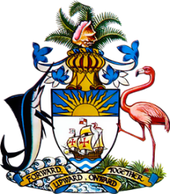

Statement by Ms. Sasha Dixon, Second Secretary
Permanent Mission of The Bahamas to the United Nations Office and Other International Organizations in Geneva
at the 39th Session of the Universal Periodic Review Working Group
Presentation of National Report by the Government of Papua New Guinea
4th November, 2021

Thank you, Madam Vice President.
The Bahamas extends a warm welcome to the delegation of Papua New Guinea. We thank the country for its comprehensive report and commend the delegation for its active and constructive engagement in this important process.
The Bahamas submits the following recommendations to Papua New Guinea:
- ratify the UN Convention against Torture and other Cruel, Inhuman or Degrading Treatment and Punishment (UNCAT);

- continue its efforts to enact the Disability Authority Bill; and
- ensure that women and girls have adequate access to sexual and reproductive health care services.

We highlight the commitment of Papua New Guinea to ensuring the promotion and protection of human rights of all its citizens, despite challenges faced, including due to the effects of climate change.

We congratulate the country on the establishment of its Independent Commission Against Corruption (ICAC) in 2020, which is an important development in the realization of fundamental rights.

We also commend the Government on introducing the ‘Early Childhood Education Policy (2020)’ which aims to promote education development of a child at infancy to age eight (8) in preparation for compulsory education

We wish the delegation every success in this UPR process.

Thank you.

