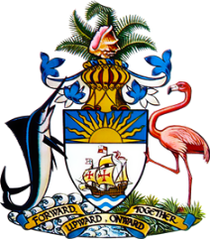

Statement by Mr. Frank Davis, Deputy Permanent Representative
Permanent Mission of The Bahamas to the United Nations Office and Other International Organizations in Geneva
at the 39th Session of the Universal Periodic Review Working Group
Presentation of National Report by the Government of Ireland
Wednesday, 10 November 2021

Thank you, Madam/Mr. [Vice] President.
The Bahamas extends a warm welcome to the delegation of Ireland.
We appreciate Ireland’s detailed national report and commend the efforts undertaken in the field of human rights, since the last review.

In a constructive Spirit, The Bahamas recommends that Ireland:

- Continues to take steps to incorporate the International Convention on the Elimination of All Forms of Racial Discrimination into the domestic legal order;

- Implements the 2019 Climate Action Plan, and advance on the Climate Change Adaptation Framework, particularly how marginalized groups will be protected

and;

- Continues to ensure that human rights and environmental protection are considered in its trade and investment strategy.

We wish Ireland every success in this UPR process.

I thank you.

(Speaking time allocated: 1 minute and 5 seconds)

