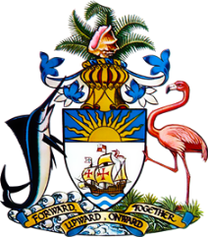

Statement by Ms. Sasha Dixon, Second Secretary
Permanent Mission of The Bahamas to the United Nations Office and Other International Organisations in Geneva
at the 39th Session of the Universal Periodic Review Working Group
Presentation of UPR Report by the Government of Hungary
2 November 2021

While extending a warm welcome to the delegation of Hungary, we commend the country for its participation in the UPR Process.

We positively note areas of progress since Hungary’s last review, including supporting families through subsidies, tax allowances and reformed nursery services; efforts to facilitate the return of mothers to the labour market and reduce the gender pay gap as well as institutional strengthening to address domestic violence.

We also welcome Hungary’s achievements in increasing its Official Development Assistance (ODA)/Gross National Income ratio.
In a constructive spirit, The Bahamas recommends that Hungary:

- Conducts a widespread public awareness campaign to address the prevalence of racist and xenophobic hate speech;

- Fully implements the national strategy for the promotion of gender equality and gives full effect to the constitutional guarantee of equality between women and men and
- Prioritises initiatives to eliminate discrimination against and segregation of Roma children in schools and takes prompt measures to reduce the educational attainment gap between Roma and non-Roma children, particularly in primary education.
We wish Hungary a successful UPR.

I thank you.

