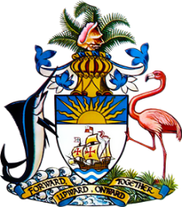

Statement by Ms. Sasha Dixon, Second Secretary
Permanent Mission of The Bahamas to the United Nations Office and Other International Organisations in Geneva
at the 39th Session of the Universal Periodic Review Working Group
Presentation of UPR Report by the Government of Greece
1 November 2021

We thank the delegation of Greece for presenting the national report and commend the country for progress made since the last review.

Noteworthy are efforts to protect the rights of Persons with Disabilities, strengthened legal and institutional provisions to prevent and combat violence against women, strategic policy measures and training aimed at countering trafficking in human beings as well as priority placed on ensuring universal access to quality health care and education services.

Legislative and other measures to combat racial discrimination are also encouraging.
With a view to fostering further progress, The Bahamas recommends that Greece:

- Undertakes an intensive national public awareness-raising campaign aimed at combating racial discrimination;
- Strengthens efforts to prevent, respond to and ensure identification of child victims of trafficking and exploitation, including through the development of an appropriate protective legal and policy framework;
- Takes steps to dismantle obstacles to effective access to education, with a view to improving school attendance rates among children in vulnerable situations.

We wish Greece a successful UPR.

I thank you.

