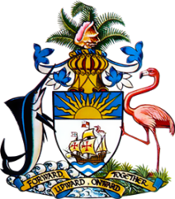

Statement by Mr. Frank Davis, Deputy Permanent Representative
Permanent Mission of The Bahamas to the United Nations Office and Other International Organizations in Geneva
at the 39thSession of the Universal Periodic Review Working Group
Presentation of National Report by the Government of Antigua and Barbuda
Monday, 8 November, 2021

Thank you, Madam/Mr.[Vice] President.
The Bahamas extends a warm welcome to the sister CARICOM delegation of Antigua and Barbuda and thanks the country for its report and commends its engagement in this UPR process.
In a constructive spirit, The Bahamas recommends that Antigua and Barbuda:

- Continue to provide adequate resources towards the initiatives which have started to help teenage mothers finish their secondary school education, at classes that can accommodate the unique challenges of being a young single mother;
- Seek technical assistance with a view to creating a specific unit staffed by trained personnel whose responsibility would include public dissemination of information concerning the human rights obligations of the State, investigating human rights issues for the purpose of creating a data bank and generating reports as and when required;
and
- Advance efforts in the drafting of Regulations regarding the Disabilities and Equal Opportunities Act.

As a fellow CARICOM Member State and Small Island Developing State (SIDS), we recognise the challenges faced by Antigua and Barbuda, including the strain that the coronavirus pandemic has put on progress towards national goals, the challenges faced by limited human resources and the disproportionate threats posed by climate change. We encourage Antigua and Barbuda to avail itself of technical assistance and capacity-building support, in accordance with its human rights priorities and call on the international community to cooperate with the country in this regard.

We wish Antigua and Barbuda every success in this UPR process.

I thank you.

