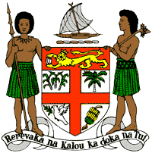
PERMANENT MISSION OF THE REPUBLIC OF FIJI TO THE UNITED NATIONS
OFFICE AND OTHER INTERNATIONAL ORGANISATIONS AT GENEVA
39TH SESSION OF THE UPR WORKING GROUP
TRINIDAD AND TOBAGO
Fiji commends Trinidad and Tobago for its progressive law reforms to facilitate better access to justice.
We offer the following recommendations:
- Ensure the meaningful participation of women, children, persons with disabilities, and local communities in the development and implementation of climate change and disaster risk reduction frameworks.

- Continue to refrain from applying the death penalty and impose an official moratorium on the death penalty.

- Initiative a process for a State review and discussion of the relevance of the death penalty to Trinidad and Tobago, with a view to consider its complete abolition.

- Take the necessary steps to combat discrimination and violence against women and children, and on the basis of sexual orientation and gender identity.

- Ratify the Convention against Torture and Other Cruel, Inhuman or Degrading Treatment or Punishment.
We wish Trinidad and Tobago a successful review.

