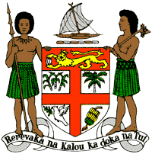
PERMANENT MISSION OF THE REPUBLIC OF FIJI TO THE UNITED NATIONS
OFFICE AND OTHER INTERNATIONAL ORGANISATIONS AT GENEVA
39TH SESSION OF THE UPR WORKING GROUP
TANZANIA
Fiji commends Tanzania for the progress made between 2015 and 2020 to ensure access to clean and safe potable water.
We offer the following recommendations:
- Ensure the meaningful participation of women, children, persons with disabilities, and local communities in the development and implementation of climate change and disaster risk reduction frameworks.

- Take the necessary steps to combat discrimination and violence against women and children, and on the basis of sexual orientation and gender identity.

- Ensure that section 154 of the Penal Code does not criminalise or is not interpreted in a manner that criminalises same-sex relations.
We wish Tanzania a successful review.

