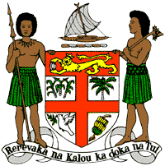
PERMANENT MISSION OF THE REPUBLIC OF FIJI TO THE UNITED NATIONS
OFFICE AND OTHER INTERNATIONAL ORGANISATIONS AT GENEVA
39TH SESSION OF THE UPR WORKING GROUP
SAINT VINCENT AND THE GRENADINES
Fiji commends Saint Vincent and the Grenadines for ratifying the Escazú Agreement in 2019 and accepting the request of the Special Rapporteur on the enjoyment of a safe, clean, healthy, and sustainable environment to visit. We further commend the moratorium on the death penalty and the absence of its use since 1993.
We offer the following recommendations:
- Ensure the meaningful participation of women, children, persons with disabilities, and local communities in the development and implementation of climate change and disaster risk reduction frameworks.

- Continue the moratorium on the death penalty.

- Initiate a process for a State review and discussion of the relevance of the death penalty to Saint Vincent and the Grenadines, with a view to consider its complete abolition.
We wish Saint Vincent and the Grenadines a successful review.

