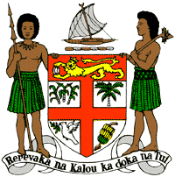
PERMANENT MISSION OF THE REPUBLIC OF FIJI TO THE UNITED NATIONS
OFFICE AND OTHER INTERNATIONAL ORGANISATIONS AT GENEVA
39TH SESSION OF THE UPR WORKING GROUP
PAPUA NEW GUINEA
Fiji commends Papua New Guinea for strengthening its legal framework against torture. We also commend Papua New Guinea’s aspiration in paragraph 37 of its national report of an ongoing progress towards ratification of the Convention against Torture. This commitment was demonstrated recently through Papua New Guinea’s participation and invaluable contributions at the Convention against Torture Initiative Pacific Online Workshop in May 2021. We look forward to Papua New Guinea’s continued engagement with the Convention Against Torture Initiative.
We offer the following recommendations:
- Ensure the meaningful participation of women, children, persons with disabilities, and local communities in the development and implementation of climate change and disaster risk reduction frameworks.

- Continue and intensify efforts towards the ratification of the Convention against Torture and Other Cruel, Inhuman or Degrading Treatment or Punishment.

- Initiate a process for a State review and discussion of the relevance of the death penalty to Papua New Guinea, with a view to consider its complete abolition.

- Take the necessary steps to combat discrimination and violence against women and children, and on the basis of sexual orientation and gender identity.
We wish Papua New Guinea a successful review.

