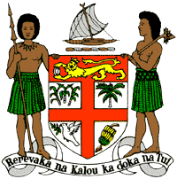
PERMANENT MISSION OF THE REPUBLIC OF FIJI TO THE UNITED NATIONS
OFFICE AND OTHER INTERNATIONAL ORGANISATIONS AT GENEVA
39TH SESSION OF THE UPR WORKING GROUP
GREECE

Fiji commends Greece’s strides in protecting the rights of persons with disabilities and its efforts to address discrimination, including on the basis of race, gender, and sexual orientation. We further commend Greece’s co-sponsorship, at the 48th HRC session, of the resolution on the right to a clean, healthy, and sustainable environment and its membership on the core group of the resolution for the establishment of a Special Rapporteur for climate change.
Fiji offers the following recommendations:
- Ensure the meaningful participation of women, children, persons with disabilities, and local communities in the development and implementation of climate change and disaster risk reduction frameworks.
- Ensure that all forms of hate crime are investigated and prosecuted with perpetrators held accountable, and to ensure that appropriate training on hate crime is provided to law enforcement officials and the judiciary.

