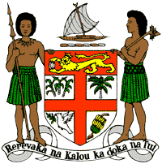
PERMANENT MISSION OF THE REPUBLIC OF FIJI TO THE UNITED NATIONS
OFFICE AND OTHER INTERNATIONAL ORGANISATIONS AT GENEVA
39TH SESSION OF THE UPR WORKING GROUP
ANTIGUA AND BARBUDA
Fiji commends Antigua and Barbuda for its resilience in enduring through hurricane Irma and building forward with a commitment to environmental protection, research, and action mindful of the direct link between the protection of the marine and coastal environment and the mitigation of harmful effects of strong hurricanes.
We offer the following recommendations:
- Ensure the meaningful participation of women, children, persons with disabilities, and local communities in the development and implementation of climate change and disaster risk reduction frameworks.

- Take the necessary steps to combat discrimination and violence against women and children, and on the basis of sexual orientation and gender identity.

- Initiate a process for a State review and discussion on the relevance of the death penalty to Antigua and Barbuda, with a view to consider the imposition of a moratorium on the death penalty and its complete abolition.
We wish Antigua and Barbuda a successful review.

