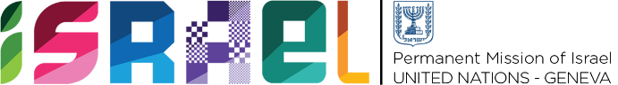 | Check against delivery  1s minute 5 seconds

Statement on behalf of the State of Israel
UPR WORKING GROUP – 39th SESSION
2 November 2021 (afternoon)

Review of Hungary

Madam President,
Israel welcomes the delegation of Hungary to the UPR and would like to thank it for its National Report.
Israel would like to commend Hungary for endorsing the working definition of antisemitism by IHRA and implementing policies on Holocaust remembrance and education. We would also like to commend it on introducing Holocaust Memorial Day into the high school curriculum.
In this regard, Israel recommends that:
- Hungary continues its work on tackling hate speech directed towards religious and racial minorities and LGBT persons.
Israel also commends Hungary for increasing the employment rate of women and launching the National Talent Program in 2018.
In this context, Israel recommends that:
- Hungary continues to take measures to increase the number of women involved in the public sector.
We also welcome that the elimination of violence against women is considered a priority and in this regard, we recommend that;
- Hungary ensures that all cases of domestic violence are reported, recorded, and fully investigated.
I thank you.

