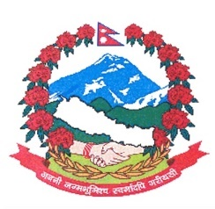
Statement by the delegation of Nepal
39th session of the Working Group on Universal Periodic Review
UPR of Eswatini, 08 November 2021

Time: 1 Min 25 secs
Words: 178

Madam President,

Nepal warmly welcomes the delegation of Eswatini to the third cycle of UPR.

Nepal appreciates the enactment of the Election of Women Members into the House of Assembly Act, 2018 to ensure at least 30% women representation in the House of Assembly and wish for its effective implementation.

The enactment of Sexual Offences and Domestic Violence Act 2018 for the prevention and protection of all persons from harm and acts of violence is noteworthy.

We encourage Eswatini to enhance efforts for the effective implementation of its development plans and national strategies aimed at reducing poverty.

In the spirit of constructive dialogue, we recommend Eswatini the following for their consideration:

- Consider ratifying the Second Optional Protocol on Civil and Political Rights aiming at the abolition of death penalty.
- Consider implementing measures to upgrade the Human Rights and Public Administration Commission to a ‘A’ category institution in line with the Paris Principles.
- Accelerate efforts to reduce maternal and neonatal mortality rates improving the quality of maternal and newborn care in health facilities.
I thank you.

