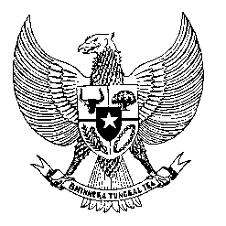

Permanent Mission
of the Republic of Indonesia to the UN, WTO,
and Other International Organizations
in Geneva

STATEMENT BY THE DELEGATION OF THE REPUBLIC OF INDONESIA
AT THE 39th SESSION OF THE UPR WORKING GROUP
CONSIDERATION OF THE UPR REPORT OF TRINIDAD AND TOBAGO
Geneva, 9 November 2021

Thank you Madame President,

My Delegation welcomes the Delegation of Trinidad and Tobago for their review and thank them for the presentation.

We appreciates measures taken since the last review cycle including those to address the backlog of cases and improve access to justice, raising the minimum legal age for marriage and other measures to further protect rights of children.

We offer the following recommendations:
- Take necessary measures to ratify the Convention against Torture and the International Convention on the Protection of All Migrant Workers and members of their family
- Create human rights education and training for governemnt officials and for law enforcement officers including through international cooperation with partners.
- Strengthen measures to prevent and combat gender-based and domestic violence with equal and meaningful participation of women in its decision making process.

We wish the Government of Trinidad and Tobago success in their review.

Thank you.

