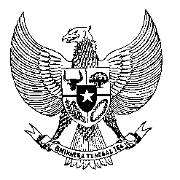

Permanent Mission
of the Republic of Indonesia to the UN, WTO,
and Other International Organizations
in Geneva

STATEMENT BY THE DELEGATION OF THE REPUBLIC OF INDONESIA
AT THE 39th SESSION OF THE UPR WORKING GROUP
CONSIDERATION OF THE UPR REPORT OF THAILAND
Geneva, 10 November 2021

Thank you Madame President,

My Delegation thank the esteemed Thailand delegation for their presentation.

We commend the progress made by Thailand since their last review, particularly in the area of children’s education, treatment of migrant workers and measures to address exploitation of elderly.

Indonesia would like to offer the following recommendations:

First to continue uphold human rights in the design and provision of Covid-19, pandemic counter measures, particularly the rights of children and person with disabilities.

Second to continue enhance the participation of local community in land conservation and and forest management, including through recognising local community’s role in global climate action agenda.

Third to take all necessary steps to immediately end forced labour and human rights abuses in the fishing industry, including by providing medical and social security services to migrant workers in the industry

We wish the Government of Thailand every success for the review and the full implementation of all accepted recommendations. Thank you.

