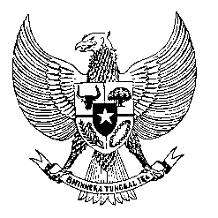

Permanent Mission
of the Republic of Indonesia to the UN, WTO,
and Other International Organizations
in Geneva

STATEMENT BY THE DELEGATION OF THE REPUBLIC OF INDONESIA
AT THE 39th SESSION OF THE UPR WORKING GROUP
CONSIDERATION OF THE UPR REPORT OF TAJIKISTAN
Geneva, 4 November 2021

Thank you Madame President,

My Delegation welcomes the Delegation of Tajikistan for their review and thank them for the presentation.

We commend Tajikistan for the adoption of measures since their last review in 2016 including the adoption of various strategic documents in the area of human rights and development, among others the National Strategy for the Development of Education: the Programme for the Prevention of Domestic Violence: Provision of Free Legal Assistance and Reform of the Juvenile Justice System and National Action Plan for Combating Trafficking in Persons and we look forward for its full implementation to reach their targets.

For this review, we offer the following recommendations:

- To strengthen the values of democracy in all sphere of life including through civic education and training program for further understanding of the electoral and political system to ensure equal participation in political and public life in and outside of electoral context.

- Enhance capacities of women to enter and partake in economic activities including by widening employment access and opportunities as well as design effective training and education program on digital and financial literacy for women, involving bilateral and international cooperation.

- Further improve access to inclusive education for all children with disabilities.

We wish the Government of Tajikistan success for the review and the full implementation for all accepted recommendations.

I thank you.

