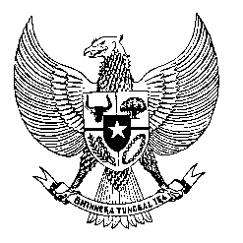

Permanent Mission
of the Republic of Indonesia to the UN, WTO,
and Other International Organizations
in Geneva

STATEMENT BY THE DELEGATION OF THE REPUBLIC OF INDONESIA
AT THE 39th SESSION OF THE UPR WORKING GROUP
CONSIDERATION OF THE UPR REPORT OF SAMOA
Geneva, 2 November 2021

Thank you Madame President,

My Delegation welcomes the Delegation of Samoa and thank them for the presentation.

We commend the launched of the six national policies and Community Sector Plan and encourage its full implementation to support realization of Samoa’s obligation under international human rights instruments. We also commend Samoa’s ratification of CRPD and accession to CAT after the 2016 UPR.

We offer the following recommendations:
- Take necessary measures to ratify the ICESCR, ICERD and ICMW and enhance national capacities for the ratification including through technical assistance cooperation with international partners.
- Improve measures to reduce the prevalence of non-communicable diseases including through health education, awareness and services.
- Improve and fully implement policies and programs to increase women’s participation in decision-making, public life and employment at all level.

We wish the Government of Samoa every success in their review.
Thank you.

