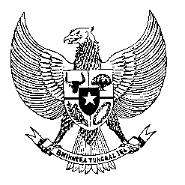

Permanent Mission
of the Republic of Indonesia to the UN, WTO,
and Other International Organizations
in Geneva

STATEMENT BY THE DELEGATION OF THE REPUBLIC OF INDONESIA
AT THE 39th SESSION OF THE UPR WORKING GROUP
CONSIDERATION OF THE UPR REPORT OF SAINT VINCENT AND THE GRENADINES
Geneva, 3 November 2021

Thank you Madame President,

My Delegation welcomes the Delegation of Saint Vincent & the Grenadines for their review and thank them for the presentation.

We take note a number of national action plans issued after their second review for the protection of women, children, health, combating human trafficking and climate. We encourage the full implementation of these national action plans to meet the state’s obligations under the relevant international human rights instruments.

We offer the following recommendations:
- Continue to take substantive measures to establish NHRI and develop national action plan of human rights for systematic and comprehensive actions for promotion and protection of human rights for all people in the country.

- Continue to take all necessary measures to effectively combat domestic violence and provide victims-based approach.

- Continue implementation of its socio-economic development programs to eradicate poverty and improve standard of living, including by providing sufficient funding and develop more training programs to increase employment and access to decent work including through bilateral and international cooperation.

We wish the Government of Saint Vincent and the Grenadines every success in their review.

Thank you.

