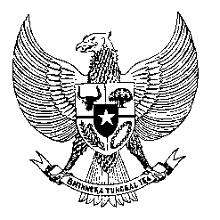

Permanent Mission
of the Republic of Indonesia to the UN, WTO,
and Other International Organizations
in Geneva

STATEMENT BY THE DELEGATION OF THE REPUBLIC OF INDONESIA
AT THE 39th SESSION OF THE UPR WORKING GROUP
CONSIDERATION OF THE UPR REPORT OF GREECE
Geneva, 1 November 2021

Thank you Madame President,

My Delegation welcomes the Delegation of Greece for their review and thank them for the presentation.

We appreciates measures taken since the last review cycle to strengthened human rights mechanism in the country, including for Ombudsman and legislative framework for the Greece National Commission for Human Rights.

We offer the following recommendations:
- Continue effort to address and prevent trafficking of persons for forced labour particularly in the agriculture industry and strengthen victims-centered approach.
- Continue implement measures to eliminate obstacles to access to education for all children including children with disabilities.
- Enhancing measures to prevent and combat violence against women and to extend those measures to reach women migrants and refugees living in camps.

We wish the Government of Greece success in their review.

Thank you.

