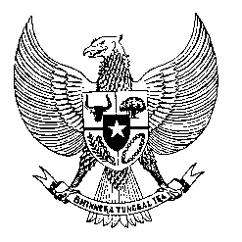

Permanent Mission
of the Republic of Indonesia to the UN, WTO,
and Other International Organizations
in Geneva

Statement
by the Delegation of the Republic of Indonesia
at the 39th Session of the UPR Working Group
Consideration of the UPR Report of Eswatini
8 November 2021

Vice-President,

Indonesia thanks the delegation of the Kingdom of Eswatini for their report.

Indonesia welcomes the wide ranging efforts that Eswatini has undertaken in developing sectoral policies in the promotion of human rights, namely in the fiels of gender equality, education and training, rights of persons with disabilities, and financial inclusion.

To further improve progress in the promotion and protection of human rights in Eswatini, Indonesia would like to recommend the following:

- Take further measures in implementing the CEDAW, in particular in curbing discrimination and violence against women;
- Continue efforts in improving prison conditions and the treatment of people in detention, involving also possible bilateral and international cooperation; and
- Consider developing a national action plan on human rights, including on the business sector;
Indonesia wishes the delegation of Eswatini a successful review.

I thank you.

(Max: 1:25)

