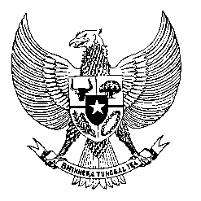

Permanent Mission
of the Republic of Indonesia to the UN, WTO,
and Other International Organizations
in Geneva

Statement
by the Delegation of the Republic of Indonesia
at the 39th Session of the UPR Working Group
Consideration of the UPR Report of Antigua and Barbuda
8 November 2021

Thank you Madame President,

Indonesia thanks the delegation of Antigua and Barbuda for their report.

Indonesia welcomes Antigua and Barbuda’s ratification of the ICCPR as recommended during the previous review cycle, as well as its efforts in tackling human trafficking.

To further improve progress in the promotion and protection of human rights in Antigua and Barbuda, Indonesia recommends the following:

- Strengthen measures to assist victims of human trafficking, taking into account the needs of particularly vulnerable groups such as women domestic workers.
- Further provide persons with disabilities with increased access to information in emergency settings and promote the inclusion of persons with disabilities in relief efforts.
- Consider developing a national action plan on human rights, including in promoting human rights respect in the business sector, and actions in combating domestic violence, including through possible bilateral and international cooperation.
Indonesia wishes the delegation of Antigua and Barbuda a successful review.

I thank you.

(Max: 1:55)

