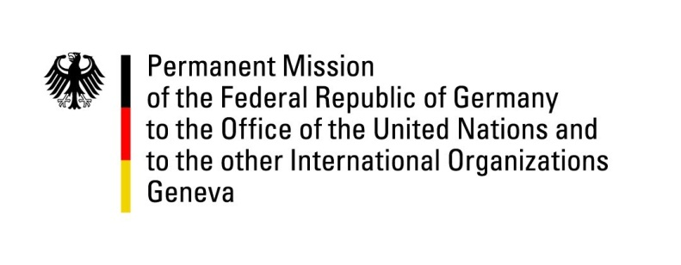

United Nations Human Rights Council

39th Session of the UPR Working Group

Geneva, 9th of November 2021

German Recommendations and advance questions to

Trinidad and Tobago

Madam President,
Germany commends the government of Trinidad and Tobago for the establishment of a Gender-based Violence Unit in the Police Service in 2020 as a response to domestic violence, as well as for passing overdue amendments in the Domestic Violence Act.
However, Germany remains concerned about the situation of refugees and the associated problem of human trafficking.

Germany therefore recommends to:

- Ratify the Convention against Torture and Other Cruel Inhuman or Degrading Treatment or Punishment.
- Ensure that asylum-seekers and refugees rights are granted under international refugee conventions by the development of national legislation.
- Address the problem of gender based violence and fully implement the "Domestic Violence Act" and thereby guarantee that particularly vulnerable migrant women have access to gender based violence services and are protected from trafficking.
- Establish an official moratorium on executions with a view to the abolishment of capital punishment and ratify the second optional protocol to the ICCPR.
- Modify the Equal Opportunities Act to include the prohibition of discrimination on sexual preference and orientation.

Thank you, Madam President.
GERMAN ADVANCE QUESTIONS TO Trinidad and Tobago:

- What concrete steps are being taken to protect women from discrimination and domestic violence?

- What concrete effects did the amendments passed on the "Domestic Violence Act" have on the implantation of the "Domestic Violence Act"?

- What concrete steps are being taken to protect female refugees, who are among the most vulnerable, from sexual exploitation and trafficking?

- When will the "National policy on refugees and asylum seekers", which was already approved by Cabinet in 2014, be put in practice?

- How will the government initiate a national discourse about the death penalty and its impacts on human rights?

