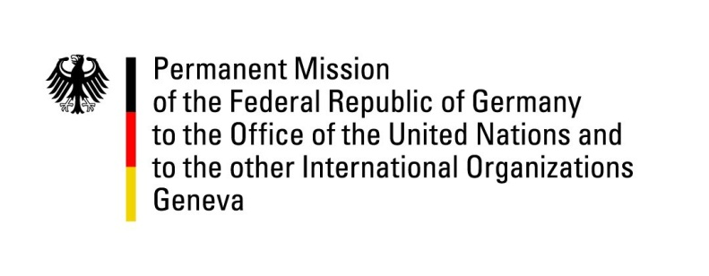

United Nations Human Rights Council

39th Session of the UPR Working Group

Geneva, 1st of November 2021

German Recommendations and advance questions to
Suriname

Madam President,
Germany welcomes the delegation of Suriname to the 39th UPR and commends Suriname for abolishing the death penalty in the military penal code in August 2021.
Germany also notes Suriname’s democratic transition of power in the summer of 2020, which can be commended as exemplary.

Germany remains concerned that the Inter-American Court of Human Rights judgement concerning the Moiwana and Saramanka People has yet to be fully implemented, and remains concerned about the increase in domestic violence since the start of the pandemic.

Germany therefore recommends to:
- implement the judgement of the Inter-American Court of Human Rights regarding the Moiwana Community and Saramanka People swiftly and completely,
- to take adequate measures to protect women and children from domestic violence.

Thank you, Madam President.
GERMAN ADVANCE QUESTIONS TO SURINAME:
- Germany would like to enquire what measures are being taken to reduce the high rates of domestic violence and child abuse which see a worldwide increase in the times of the Covid-19 pandemic?
- Germany would like to enquire what measures Suriname has taken in order to ensure access to health care and education for the indigenous population in Suriname?

