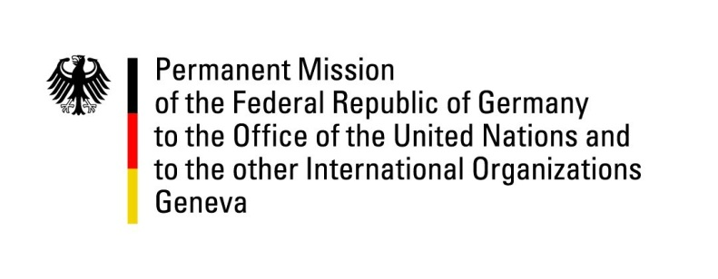

United Nations Human Rights Council

39th Session of the UPR Working Group

Geneva, 2th of November 2021

German Recommendations to

Saint Vincent and the Grenadines

Madam President,
Germany acknowledges the work of the government of Saint Vincent and the Grenadines in safeguarding the health and the lives of its citizens in the Covid crisis, exacerbated by the volcano eruption of La Soufrière in April 2021. It is very remarkable that no human lives were lost by the volcano eruption due to the preparedness and management of the government in combination with the timely evacuation of the main island.

Germany remains concerned about the continued existence of the death penalty in St. Vincent and the Grenadines and about the ongoing criminalization of consensual sexual activity between persons of the same sex.

Germany therefore recommends to:

- Immediately introduce an official moratorium on the death penalty.

- Ratify the Second Optional Protocol to the International Covenant on Civil and Political Rights aiming at the abolition of the death penalty; as well as the Optional Protocol of the Convention against Torture.
- Pass anti-discrimination legislation in order to prohibit discrimination on grounds of gender identity and sexual orientation.

Thank you, Madam President.

