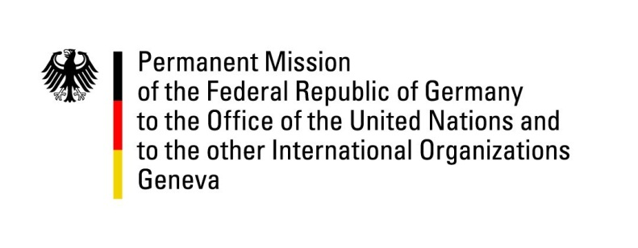

United Nations Human Rights Council

39th Session of the UPR Working Group

Geneva, 4th of November 2021

German Recommendations and advance questions to
Papua New Guinea

Madam President,
Germany welcomes the delegation of Papua New Guinea and commends the government for the renewal of its nationally determined contributions under the Paris Agreement and the commitment to adopt a gender-responsive, human rights-based approach in their implementation.

Germany remains particularly concerned about numerous reports of police violence and about the situation of women and children who continue to be disproportionately affected by crime and acts of violence. Furthermore, in light of reports about upcoming executions, we reiterate our call to abolish the death penalty.

Germany therefore recommends to

- effectively enforce the provisions of the Family Protection Act to protect women and children from violence within the family and from violence in government facilities;
- Adopt an immediate moratorium on the execution of the death penalty, with a view to its complete abolition;
- effectively investigate, prosecute and punish all acts of security forces alleged to relate to torture, ill-treatment, extrajudicial killings, and sexual violence;
- Fully ensure sexual and reproductive health rights;
- Repeal sections 210 and 212 of the Criminal Code Act in order to address discrimination based on sexual orientation and gender identity.

Thank you, Madam President.
GERMAN ADVANCE QUESTIONS TO PAPUA NEW GUINEA:
- Has the National Action Plan against sorcery-related violence been implemented? What concrete measures have been taken? By what means is the situation showing improvement?
- What is being done to combat discrimination and violence against LGBTI persons? What efforts are under way to decriminalize sex between men?
- In light of the pandemic, what is being done to improve the capacity of the health system and to ensure access to adequate health care, especially in remote areas? How does Papua New Guinea ensure that measures against the pandemic are proportionate and comply with human rights?
- How does Papua New Guinea protect the right to freedom of expression and assembly of activists and indigenous communities who draw attention to climate and environmental problems? How does the government ensure victims of business-related human rights violations obtain remedies?

