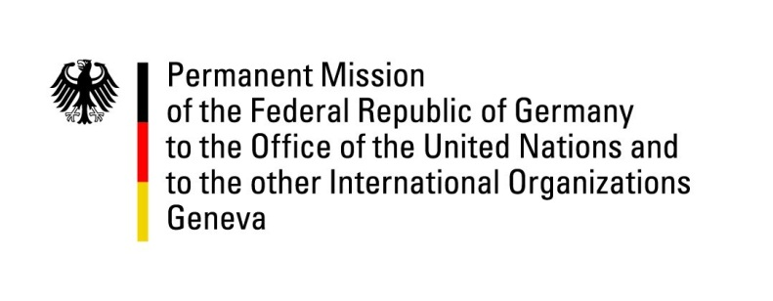

United Nations Human Rights Council

39th Session of the UPR Working Group

Geneva, 10th of November 2021

German Recommendations and advance questions to
Ireland

Madam President,
Germany welcomes the delegation of Ireland. Germany appreciates Ireland’s steadfast commitment to the promotion and protection of human rights worldwide, especially but not only its active role in the Human Rights Council. Germany commends Ireland for its considerable efforts to protect women's health with new legislation regarding abortion and domestic violence. We also acknowledge Ireland's progress in ratifying Human Rights conventions to which it has been signatory.

Germany underscores the importance of addressing the increase of women and children seeking support from domestic violence during the Covid-19 pandemic. Furthermore, ongoing discrimination against Travellers and Roma and their disproportionate representation in the prison system can inter alia be addressed by adequate national anti-racism measures and a strategy for the inclusion of Travellers and Roma to provide improvements in the fields of Health, Education, Political Participation, Employment, Housing, and others.

Germany recommends to:
- ratify the Optional Protocol to the Convention against Torture without delay.
- review Articles 40 and 41 of the Irish constitution with a view to abandon formulations that potentially promote gender discrimination.

Thank you, Madam President.
GERMAN ADVANCE QUESTIONS TO IRELAND:

- Which steps will Ireland take following the recommendation of its Citizens' Assembly that Article 41(2) of the Irish constitution be deleted and replaced with gender-neutral wording?
- How will Ireland increase its number of refuge spaces in order to match the requirements of the Council of Europe Convention on Preventing and Combating Violence against Women and Domestic Violence?
- How will Ireland support and compensate the victims of Mother and Baby Homes? How and when will Ireland implement the recommendations made by the Commission of Investigation, and which, if any, further measures will be taken?
- Which concrete aims will Ireland take, and when, to end discrimination against Travellers and Roma, especially women, and which mechanisms will be put in place to ensure progress in the fields of Traveller Health, Education, Political Participation, Employment, Housing, and others? How can Ireland ensure that local authorities fully spend Traveller accommodation budgets?

