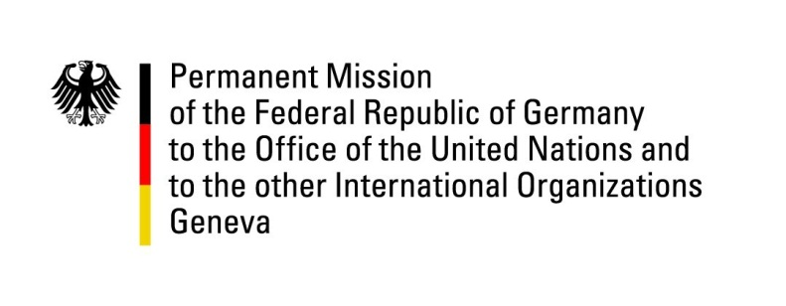

United Nations Human Rights Council

39th Session of the UPR Working Group

Geneva, 1st of November 2021

German Recommendations and advance questions to
Greece

Madam President,
Germany welcomes the delegation of Greece and commends Greece for its considerable efforts to grant unaccompanied minor refugees and unaccompanied minor migrants housing, education and an efficient system of guardianship. We acknowledge the particularly difficult situation that Greece faces with regard to such unaccompanied minors and the considerable progress it has made so far.

Nevertheless, Germany remains concerned about a remaining number of minors living in insecure circumstances and about how the system of guardianship is actually put into practice.

Germany therefore recommends to:
- improve the conditions of those unaccompanied minors that are still living in insecure circumstances
- review the system of guardianship and its functionality in practice.

Thank you, Madam President.
GERMAN ADVANCE QUESTIONS TO Greece:
- What are the experiences that Greece has made in its considerable efforts to grant housing, education and an efficient system of guardianship to unaccompanied minor refugees and unaccompanied minor migrants?

