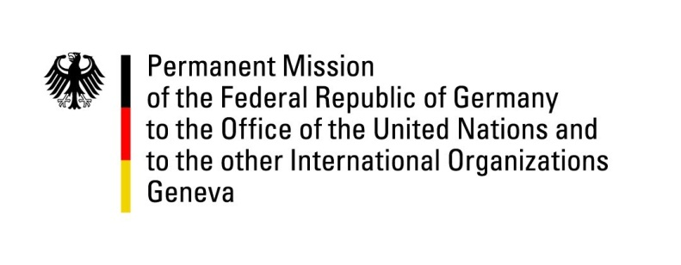

United Nations Human Rights Council

39th Session of the UPR Working Group

Geneva, 5th of November 2021

German Recommendations and advance questions to

Eswatini

Madam President,
Germany welcomes the delegation of Eswatini.
We commend Eswatini for having enacted the "Sexual Offences and Domestic Violence Bill", which helps to fight impunity for sexual and gender based violence.
Germany echoes the concerns of the Secretary-General regarding the ongoing developments in Eswatini, including the recent deployment of armed security forces at various schools, reports of excessive use of force in response to student demonstrations and the indefinite closure of schools.
Germany urges the government to refrain from violence and to ensure that security forces act in conformity with relevant international human rights standards, including the CRC.

Germany recommends to:
- Enter into a genuine, inclusive and comprehensive dialogue with the demonstrators.
- Withdraw all criminal charges brought against human rights defenders and political opponents under the Suppression of Terrorism Act of 2008, and repeal or amend this act with a view to
- Accede to the OPCAT and take necessary steps to prevent torture and other human rights violations by law enforcement and security services, including by ensuring impartial investigations of all allegations, prosecuting perpetrators, and implementing human rights training programs.

Thank you

