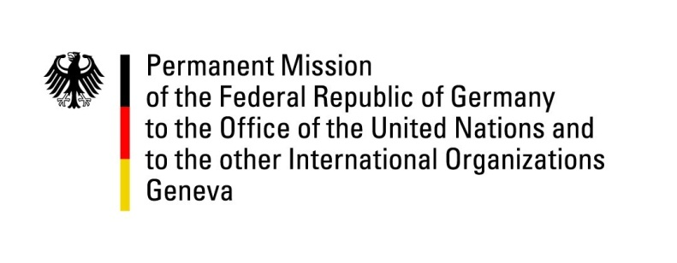

United Nations Human Rights Council

39th Session of the UPR Working Group

Geneva, 8th of November 2021

German Recommendations and advance questions to
Antigua and Barbuda

Madam President,
Germany welcomes the delegation of Antigua and Barbuda and commends its government for successfully safeguarding its population and its right to health during the COVID-19 pandemic.
Germany notes that the government in 2019 established a specialised sexual violence model court and also amended laws concerning the penalties against trafficking in human beings.

However, Germany remains concerned that Antigua and Barbuda’s indecency statutes continue to criminalize male consensual same-sex conduct. Germany also notes with concern that the death penalty remains in place, even though no executions have taken place since 1991.

Germany therefore recommends to:
- change the indecency statutes with the aim of decriminalising male consensual same-sex conduct,
- establish a formal moratorium as an initial step towards abolishing the death penalty,
- ratify the Second Optional Protocol of the International Covenant on Civil and Political Rights, and the optional protocol on CAT.
- ensure that places of detention comply with the Nelson Mandela rules

Thank you, Madam President.
GERMAN ADVANCE QUESTIONS TO ANTIGUA AND BARBUDA:
- Germany commends Antigua and Barbuda for establishing a specialised sexual violence model court and would like to enquire whether this has contributed to the fight against related offences? Could case backlogs be reduced?
- Germany wishes to enquire whether there are concrete plans to establish a national gender policy?

